GIT_BRANCHING

21.First take a backup of your assignments & projects.This is required because due to incorrect Git
Operation you may lose your files.

22. Create an empty directory ‘Assignments’ and cd to ‘Assignment’ and cd to ‘Assignment’.
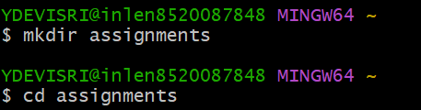

23.Create a file readme.txt inside ‘assignment’ and write few lines about the contents of
‘assignment’ folder.

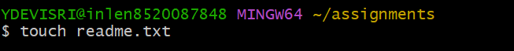

24.commit readme.txt file.
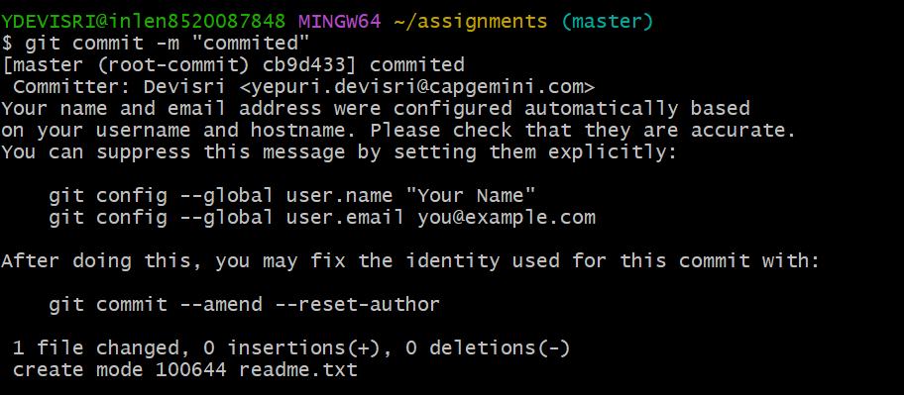

25.now create a new branch ‘html-assignment’.

26.switch to ‘html-assignment’

27. copy all HTML assignment inside ‘assignment’ folder
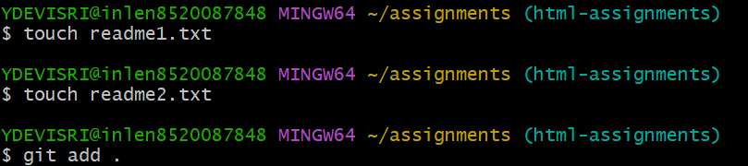

28.Commit HTML assignments into ‘html-assignments’ branch
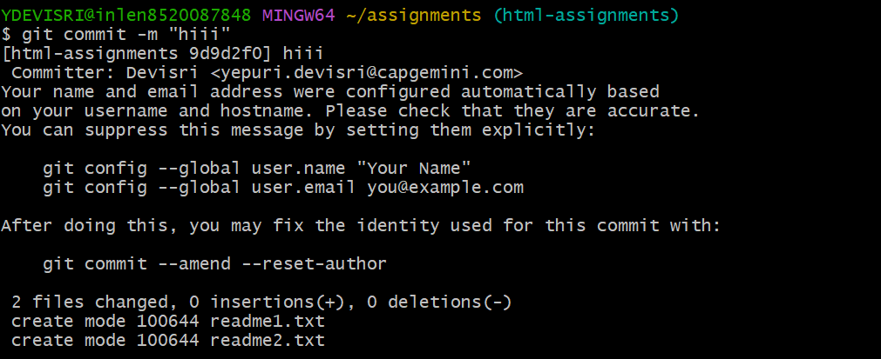

29.Make minor changes into few files belonging to ‘html-assignments’ branch.
30.Commit those changed files.
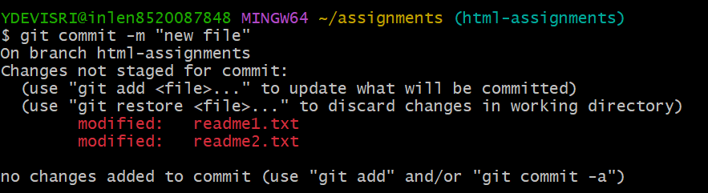
31.switch to master branch.
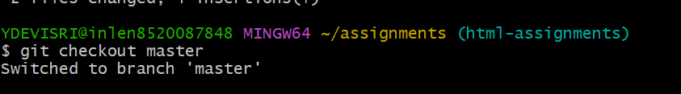

32.Make minor changes into readme.txt file and commit those changes into master.
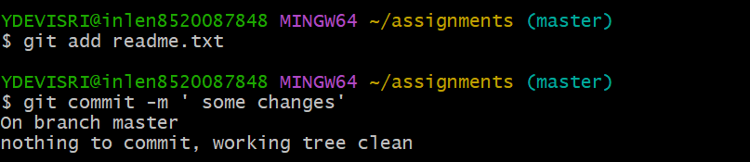

33.again switch to ‘html-assignments’ branch

34.Make minor changes into few files belonging to ‘html-assignments’ branch.

35.commit those changes.
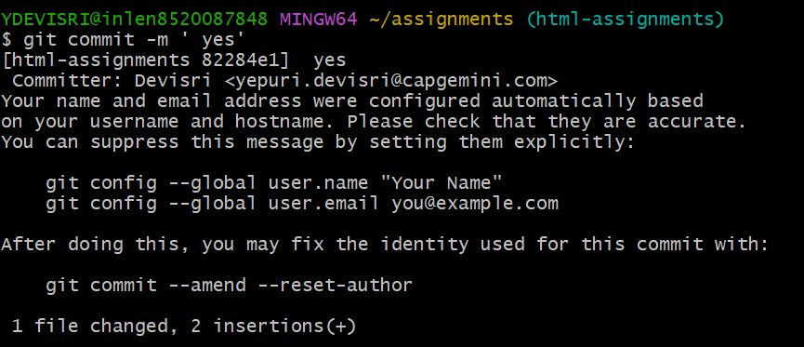

36. switch to master.
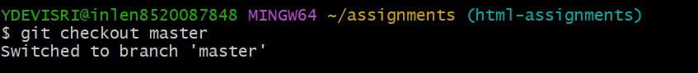

37. Merge ‘html-assignments’ branch into master. Confirm all html-assignments are shown in master.
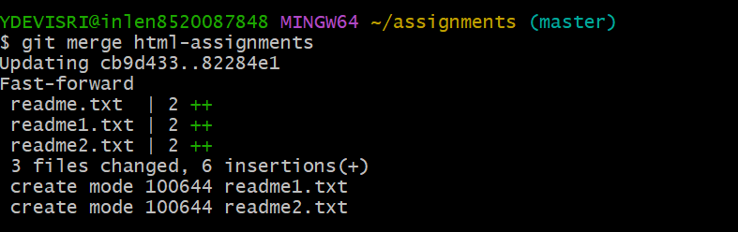

38.Finally delete the ‘html-assignments’ branch.
